Julius Ranoa

CSC 121 001 Computer Science I

Programming Finals

**Screenshot of console window**

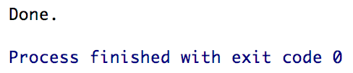

**Circle.h**



**Circle.cpp**



**main.cpp – Part 1 of 3**



**main.cpp – Part 2 of 3**



**main.cpp – Part 3 of 3.**



**radius.dat**

*\* The contents below are copied and directly pasted into Word.*



**circleData.txt**

